

Track 1: AI for Accounting SW 1

Project Feature Report

Developing a Conceptual Model for AI-Based Stock Market Forecasting Using Structured and Unstructured Data

Marwan Atef Ismail - Student ID: 58-1460
Supervisor: Dr. Gamal Kassem
Faculty of Management Technology - Business Informatics
The German University in Cairo

Table of Contents
1. Project Feature 2
2. Business Processes 2
2.1. Business Process 1 - Data Ingestion & Indicator Computation 3
2.2. Business Process 2 - Signal Generation & Survival Estimation 3
2.3. Business Process 3 - Output Delivery & AI Interaction 3
3. Use-Case Diagram 3
4. Business Process Diagram (BPMN) 4
5. User Stories 5
6. Field Requirements / Business Rules 6
7. Wireframe 6
8. Test Cases 8

Figure 1: Use-Case Diagram 4
Figure 2: BPMN Model 5
Figure 3: WireFrame 7

Project Feature
The main component of this project is a hybrid AI-based stock market forecasting system that fills a huge gap in the current forecasting system: existing models are able to predict the direction of the stock trend, but none of them are able to predict its length of time before it reverses. The system consists of a Cox Proportional Hazards (Cox PH) survival model for estimating time to reversal and a traditional composite signal scorer for predicting in which direction the trend is moving, along with a structured PostgreSQL database layer and an NLP based VADER sentiment pipeline.

Alphabet Inc. (GOOGL) is used as a reference equity to demonstrate it as a fully functional web application that yields a single output, which consists of:

• Which trading signals to execute, as determined by the best performing of the three signals listed above.The best performing of the three above trading signals, a directional trading signal (Buy / Hold / Sell).
Survival curves with reversal probabilities at 3, 5 and 7 days horizon.

• An estimated length of the trend
A straightforward explanation panel and AI chat user interface for interactive decision support.

Business Processes
The proposed system operates through three interconnected business processes that together transform raw market data into actionable trading signals. Each process builds on the output of the previous one, forming a pipeline that moves from data ingestion and preprocessing, through dual-model inference, to interpretable output delivery and AI-assisted interaction. The processes are designed in alignment with the KDD and CRISP-DM data science frameworks to ensure consistency, reproducibility, and practical usability.

Business Process 1 - Data Ingestion & Indicator Computation
The process is used to retrieve and preprocess raw market data from the system when a user query is issued. When the trader enters a stock ticker symbol, the system goes to the yfinance API and fetches one year of the DailySnapshot data (Open, High, Low, Close, Volume) and stores it in the DailySnapshot database table. At the time, the system also retrieves the top 10 financial news headlines from the web and passes them through the VADER sentiment analysis pipeline to generate a sentiment score. Technical indicators RSI (14 days), MA7, MA30 and Bollinger Bands are calculated from the cached snapshot. This business process provides consistency with the down-stream modeling components working on pre-processed data instead of raw API data.

Business Process 2 - Signal Generation & Survival Estimation
This process refers to the dual-model inference pipeline which generates the main inference product of the system. With the arrival of up-to-date technical indicators and sentiment scores, two parallel paths are performed. The composite signal scorer in the first path takes in RSI level, moving average crossover structure, 7-day linear regression forecast and the sentiment score from the VADER sentiment analysis tool and merges it into one signal score that is thresholded to generate a Buy, Sell or Hold signal. The second path provides the Cox PH survival model with the current trend age and 4 covariates: RSI, volume decline flag, Bollinger Band proximity, and market regime and generates a conditional survival curve that represents the probability of the trend continuing over future time horizons. The outputs are combined to create a single trading signal and stored in the Predictions database table.

Business Process 3 - Output Delivery & AI Interaction
This process includes the way the fabricated signal is displayed to the trader. The Trend Clock component shows the trend direction, the number of days that the trend has been following, the median number of days remaining in the trend, and the chance of a trend reversal at 3, 5 and 7 days. The traditional signal output is displayed on a split screen with a survival curve for comparison. The explanation panel in plain language shows the factors that are causing the signal to be active. The AI chat interface gets the entire analysis context, and traders can ask the LLM natural language questions, for it to provide grounded answers that refer to the current RSI, composite score and survival estimates.

Use-Case Diagram
The e use-case diagram below illustrates the two main actors in the AI Stock Forecasting System: the Trader / Investor and the System Administrator, along with the use cases that each may have access to.

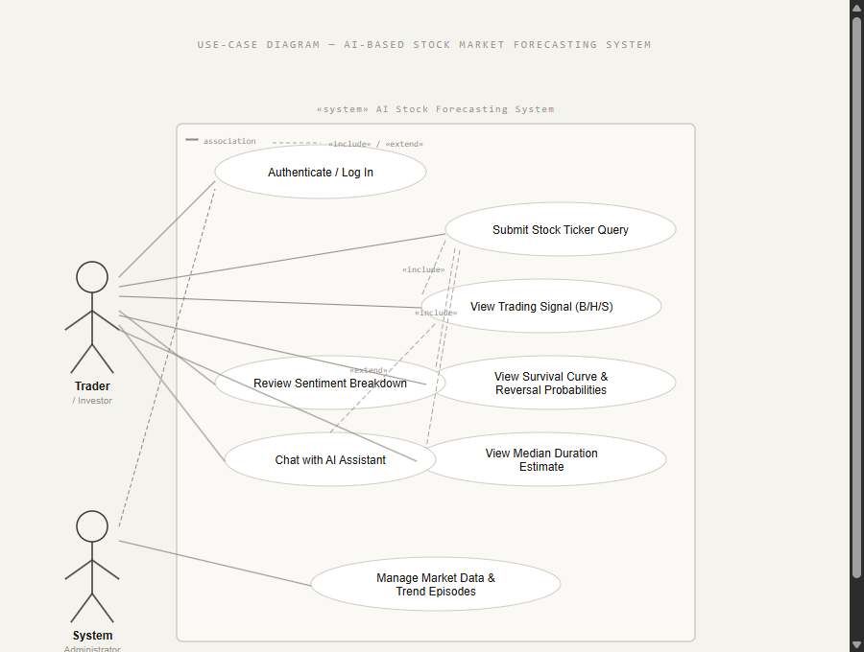

Figure 1: Use-Case Diagram

Actor descriptions:
The primary user is the Trader / Investor who authenticates, submits ticker queries and views trading signals, survival curves, median duration estimates, sentiment breakdowns, and interacts with the AI chat assistant.

Market data and trend episodes are managed in the backend database by System Administrator for data quality and retrainability of the models.

Key use-case relationships:
• Submit Stock Ticker Query <<include>> View Trading Signal (B/H/S) - each query yields a signal.
Every query will also give survival output using the Stock Ticker Query <<include>> View Survival Curve & Reversal Probabilities.

Sentiment Breakdown <<extend>> View Trading Signal – extends the signal view, inputted in the sentiment panel.

Business Process Diagram (BPMN)
The proposed hybrid framework for stock market forecasting using AI involves three swim lanes: User, Processing Layer, and Data Layer, which are mapped out in the BPMN diagram below. The diagram has been created based on the BPMN 2.0 notation. This process starts with a query from the user to the market.

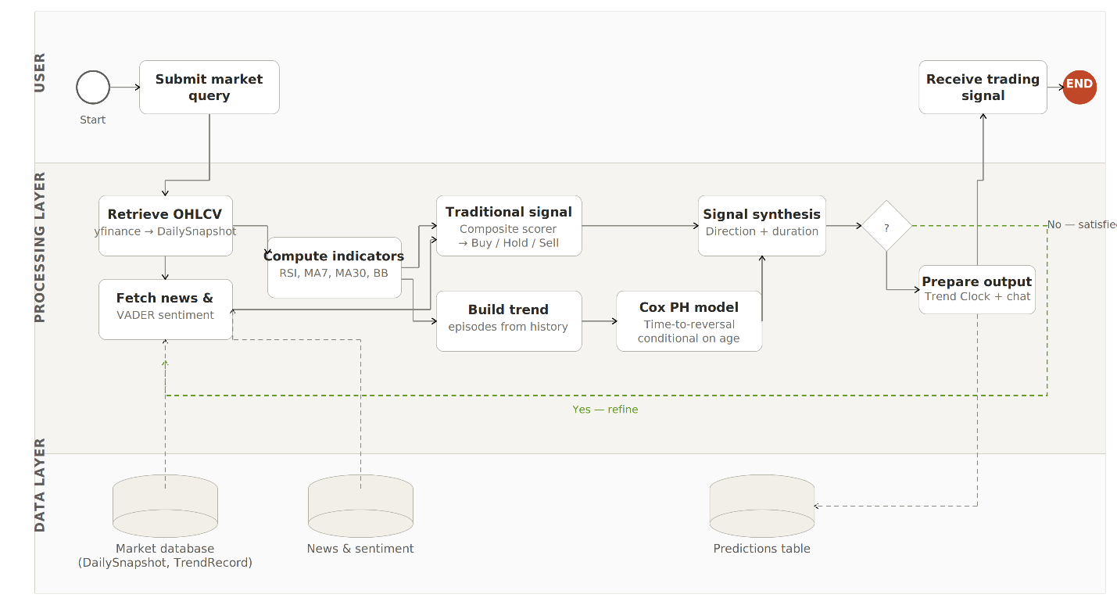

Figure 2: BPMN Model

The Processing Layer fetches OHLCV data and news sentiment in parallel, calculates technical indicators and distributes them to two parallel modelling streams. The signal synthesis output is fed into a gateway to check the quality of the signal; if the signal is not of sufficient quality, it is sent back for refinement through the Data Layer. When it is ready, the finalised signal is ready and sent to the user, and the process is finished.

User Stories
The following user stories decompose the three business processes into functional epics that define the behavioral requirements of the system.

Q-01 | Authentication & Access | As a Trader/Investor, I want to authenticate and log in securely so that I can access personalised stock analysis features.
REQ-02 | Stock Query & Analysis | As a Trader/Investor, I want to submit a stock ticker query so that the system retrieves and analyses current market data for that equity.
REQ-03 | Signal Output | As a Trader/Investor, I want to view a Buy / Hold / Sell trading signal so that I can make an informed directional trading decision.
REQ-04 | Survival Analysis Output | As a Trader/Investor, I want to view the survival curve and reversal probabilities at 3, 5, and 7 days so that I know the timing risk of the current trend.
REQ-05 | Duration Estimation | As a Trader/Investor, I want to see the median duration estimate before trend reversal so that I can plan my entry and exit points.
REQ-06 | Sentiment Insight | As a Trader/Investor, I want to review the sentiment breakdown from financial news so that I understand how market psychology is influencing the signal.
REQ-07 | AI Interaction | As a Trader/Investor, I want to chat with the AI assistant about a stock so that I can ask natural language questions and receive grounded analytical responses.
REQ-08 | System Administration | As a System Administrator, I want to manage market data and trend episodes so that the database remains accurate and the Cox model can be retrained.

Field Requirements / Business Rules
The following table defines the key data fields displayed in the system interface and the business rules that govern their computation and presentation.

Ticker Symbol | Text (string) | Must be a valid NASDAQ/NYSE ticker (e.g. GOOGL). System rejects unknown tickers.
RSI (14-day) | Numeric (0–100) | RSI > 70 flags overbought; RSI < 30 flags oversold. Used in composite signal scoring.
MA7 / MA30 | Numeric | MA7 > MA30 contributes a positive signal score; MA7 < MA30 contributes a negative score.
VADER Sentiment Score | Numeric (−1 to +1) | Derived from latest 10 news headlines. Score ≥ +0.05 = Positive; ≤ −0.05 = Negative; otherwise Neutral.
Composite Score | Numeric | Weighted sum of RSI, MA cross, LR forecast, and VADER score. Score > 0.2 = BUY; < −0.2 = SELL; else HOLD.
Reversal Probability | Percentage (%) | Computed at 3, 5, and 7-day horizons from the Cox PH survival model. Conditioned on current trend age.
Median Duration | Integer (days) | Estimated remaining days before trend reversal as derived from the Cox survival curve.
Trading Signal Output | Enum: BUY/HOLD/SELL | Final signal displayed to the trader. Cannot be modified by the user; read-only system output.

Wireframe
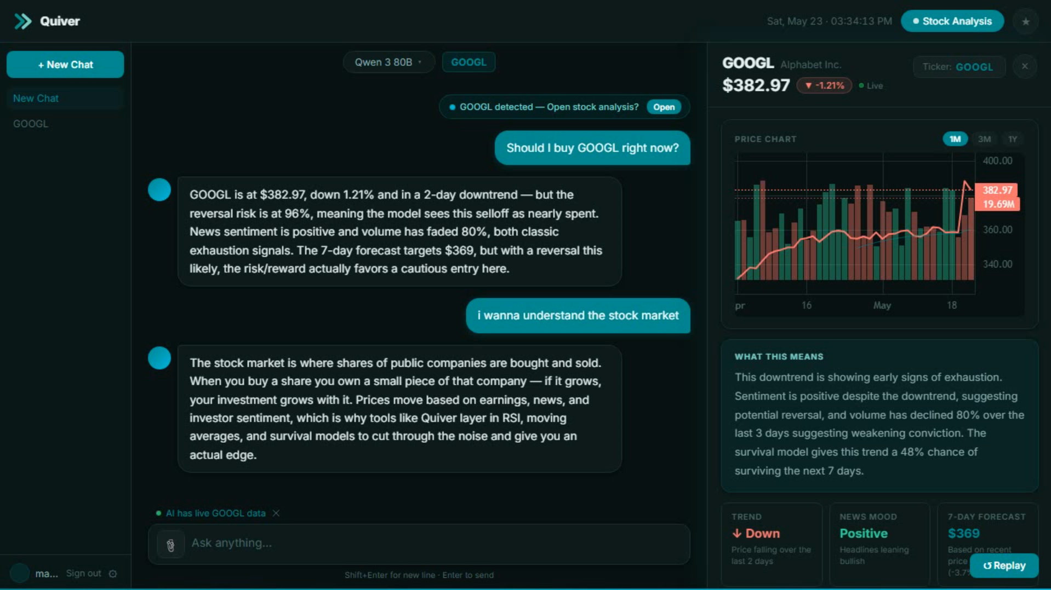

Figure 3: WireFrame

The Quiver application interface is the output layer of the proposed framework as depicted in the wire frame above. The user interface consists of two main panes:

The chat panel is used by the trader to ask a natural language question about any stock. If a ticker is found in the conversation (GOOGL), the system will automatically present the opening of the stock analysis panel. The AI assistant gives grounded and contextually appropriate answers when the user asks a question, referring to a real-time chart in which he/she can see the current price, direction of the trend, the risk percentage of the reversal, the sentiment reading, the behaviour of the volume, the price forecast for the next 7 days. This achieves direct realisation of the LLM Output Module in the conceptual model.

Right Panel Live Stock Analysis The right panel shows a real time analysis card for the stock being queried (GOOGL at $382.97, −1.21%). It includes:

A price chart with 1 month OHLCV history and moving average overlaid.

• A "What This Means" explanation panel at the end that summarizes the active risk factors in easy-to-understand terms, that the trend was in a state of exhaustion, that sentiment was positive even though the trend was down, and that the trend had a 48% chance of continuing for the next 7 days, according to the survival model.

A Trend indicator indicating the direction of the trend (Down)
Recent average and market sentiment (Positive) indicated by a news mood tone.News mood tone indicator for recent average and market mood (Positive).

• A 7-Day Forecast displaying the price range ($369)
The split layout is designed to directly satisfy the requirements of interpretability and usability , to present complex statistical outputs in a way that traders with no quantitative background can understand.

Test Cases
The following test cases are used to validate the functional requirements and important system behaviors that were identified during solution design.
TC-01 | User logs in successfully | 1) Navigate to login. 2) Enter valid credentials. 3) Submit. | User is authenticated and directed to the Dashboard.
TC-02 | Submit valid ticker query | 1) Enter 'GOOGL' in ticker field. 2) Click Analyze. | System retrieves OHLCV data, computes indicators, and displays trading signal and survival analysis.
TC-03 | Submit invalid ticker | 1) Enter 'XXXX' in ticker field. 2) Click Analyze. | System displays an error: 'Ticker not found. Please enter a valid symbol.'
TC-04 | View BUY trading signal | 1) Submit GOOGL. 2) Observe Trading Signal card. | Signal card displays BUY in green with RSI, MA, LR Forecast, Sentiment, and Composite Score.
TC-05 | View reversal probabilities | 1) Submit GOOGL. 2) Observe Trend Reversal Risk card. | Reversal probabilities shown at 3, 5, and 7 days with survival curve rendered correctly.
TC-06 | Chat with AI assistant | 1) Type 'What does the signal mean for GOOGL?' 2) Click Send. | AI assistant responds with grounded analysis referencing current RSI, signal, and survival estimate.
TC-07 | Cox model unavailable fallback | 1) Disable Cox model. 2) Submit ticker query. | System falls back to parametric hazard model and still returns survival estimate without crashing.

